Model coefficients for the best *N*-mixture model predicting abundance of Alder Flycatcher *Empidonax alnorum* from LIDAR-based data at the 150-m scale (AIC= 145) (A), and 500-m scale (AIC= 152.18) (B), along with predicted abundances of this species in the Kirby grid from these respective models (C-D).

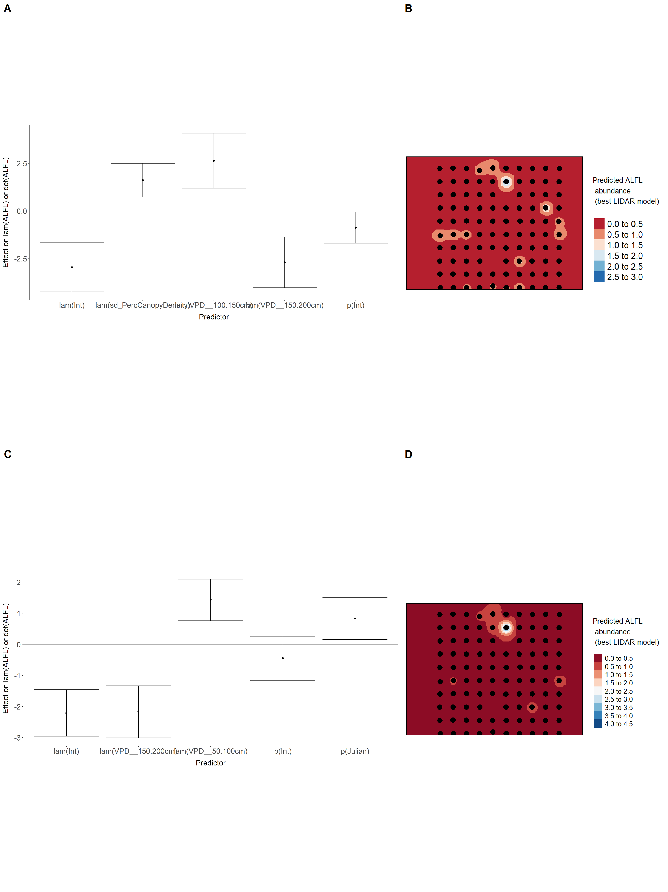

Model coefficients for the best *N*-mixture model predicting abundance of American Robin *Turdus migratorius* from LIDAR-based data at the 150-m scale (AIC= 285.99) (A), and 500-m scale (AIC= 286.04) (B), along with predicted abundances of this species in the Kirby grid from these respective models (C-D).

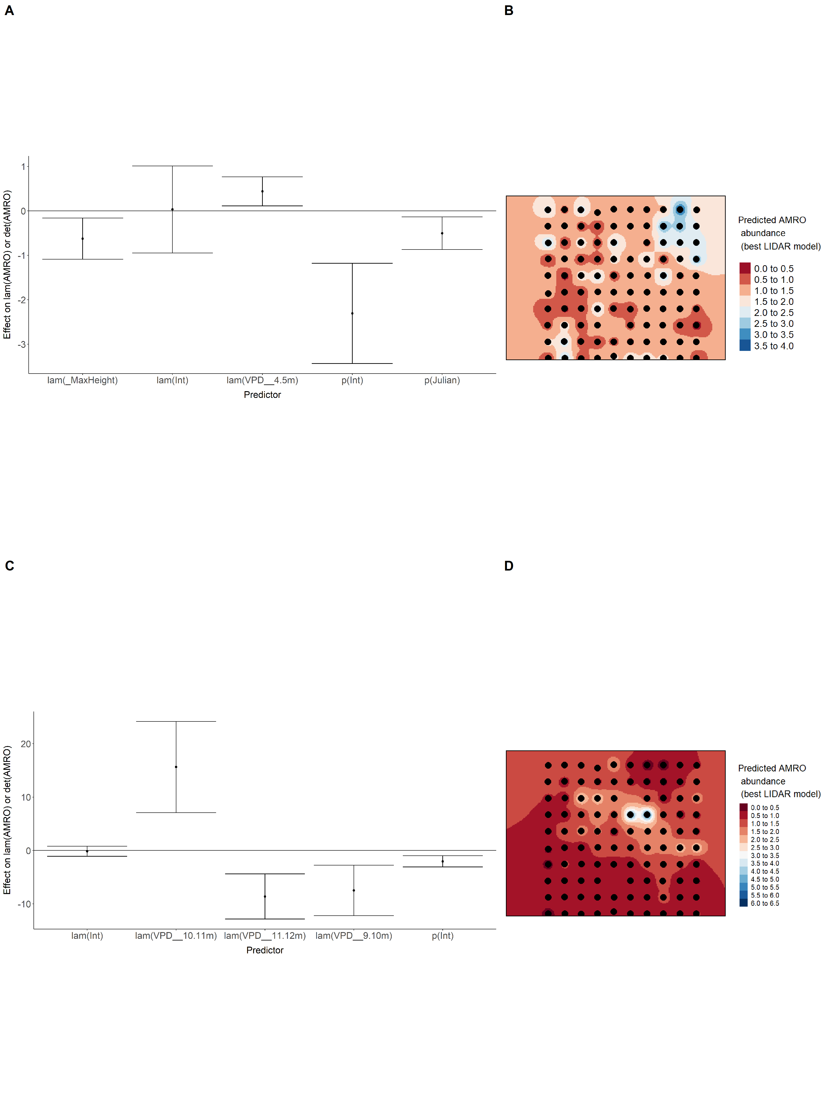

Model coefficients for the best *N*-mixture model predicting abundance of Boreal Chickadee *Poecile hudsonicus* from LIDAR-based data at the 150-m scale (AIC= 127.93) (A), and 500-m scale (AIC= 130.84) (B), along with predicted abundances of this species in the Kirby grid from these respective models (C-D).

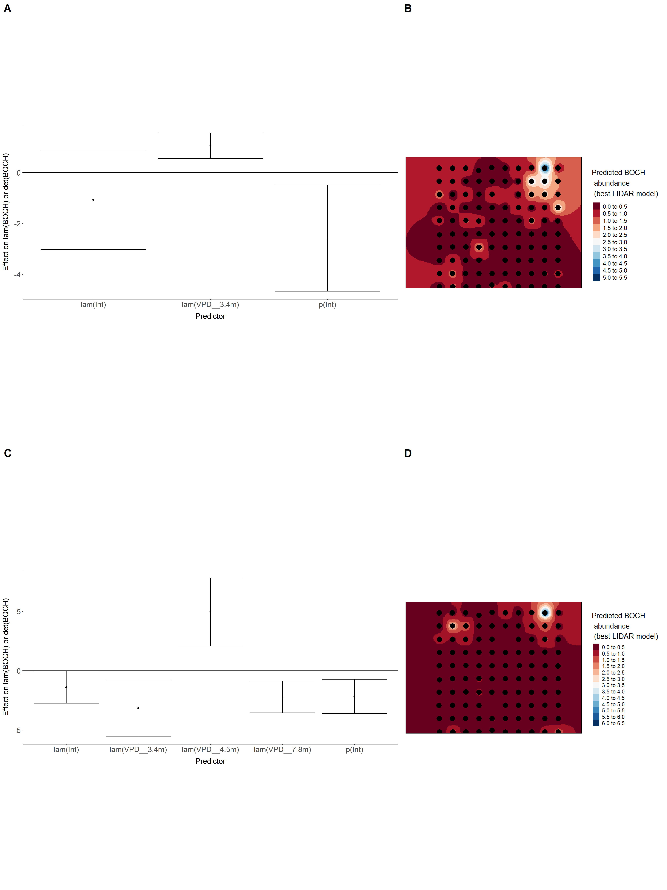

Model coefficients for the best *N*-mixture model predicting abundance of Cedar Waxwing *Bombycilla cedrorum* from LIDAR-based data at the 150-m scale (AIC= 126.29) (A), and 500-m scale (AIC= 123.71) (B), along with predicted abundances of this species in the Kirby grid from these respective models (C-D).

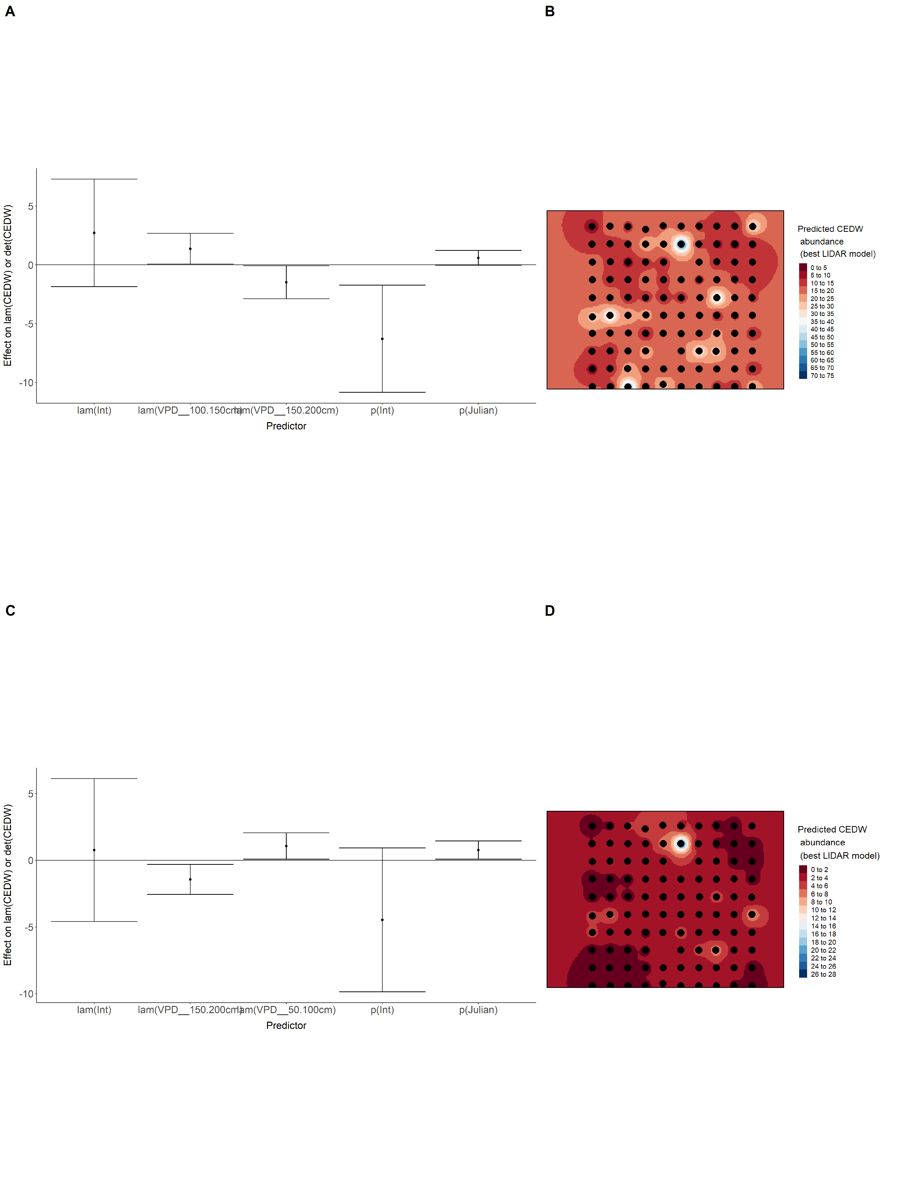

Model coefficients for the best *N*-mixture model predicting abundance of Chipping Sparrow *Spizella passerina* from LIDAR-based data at the 150-m scale (AIC= 550.27) (A), and 500-m scale (AIC= 574.45) (B), along with predicted abundances of this species in the Kirby grid from these respective models (C-D).

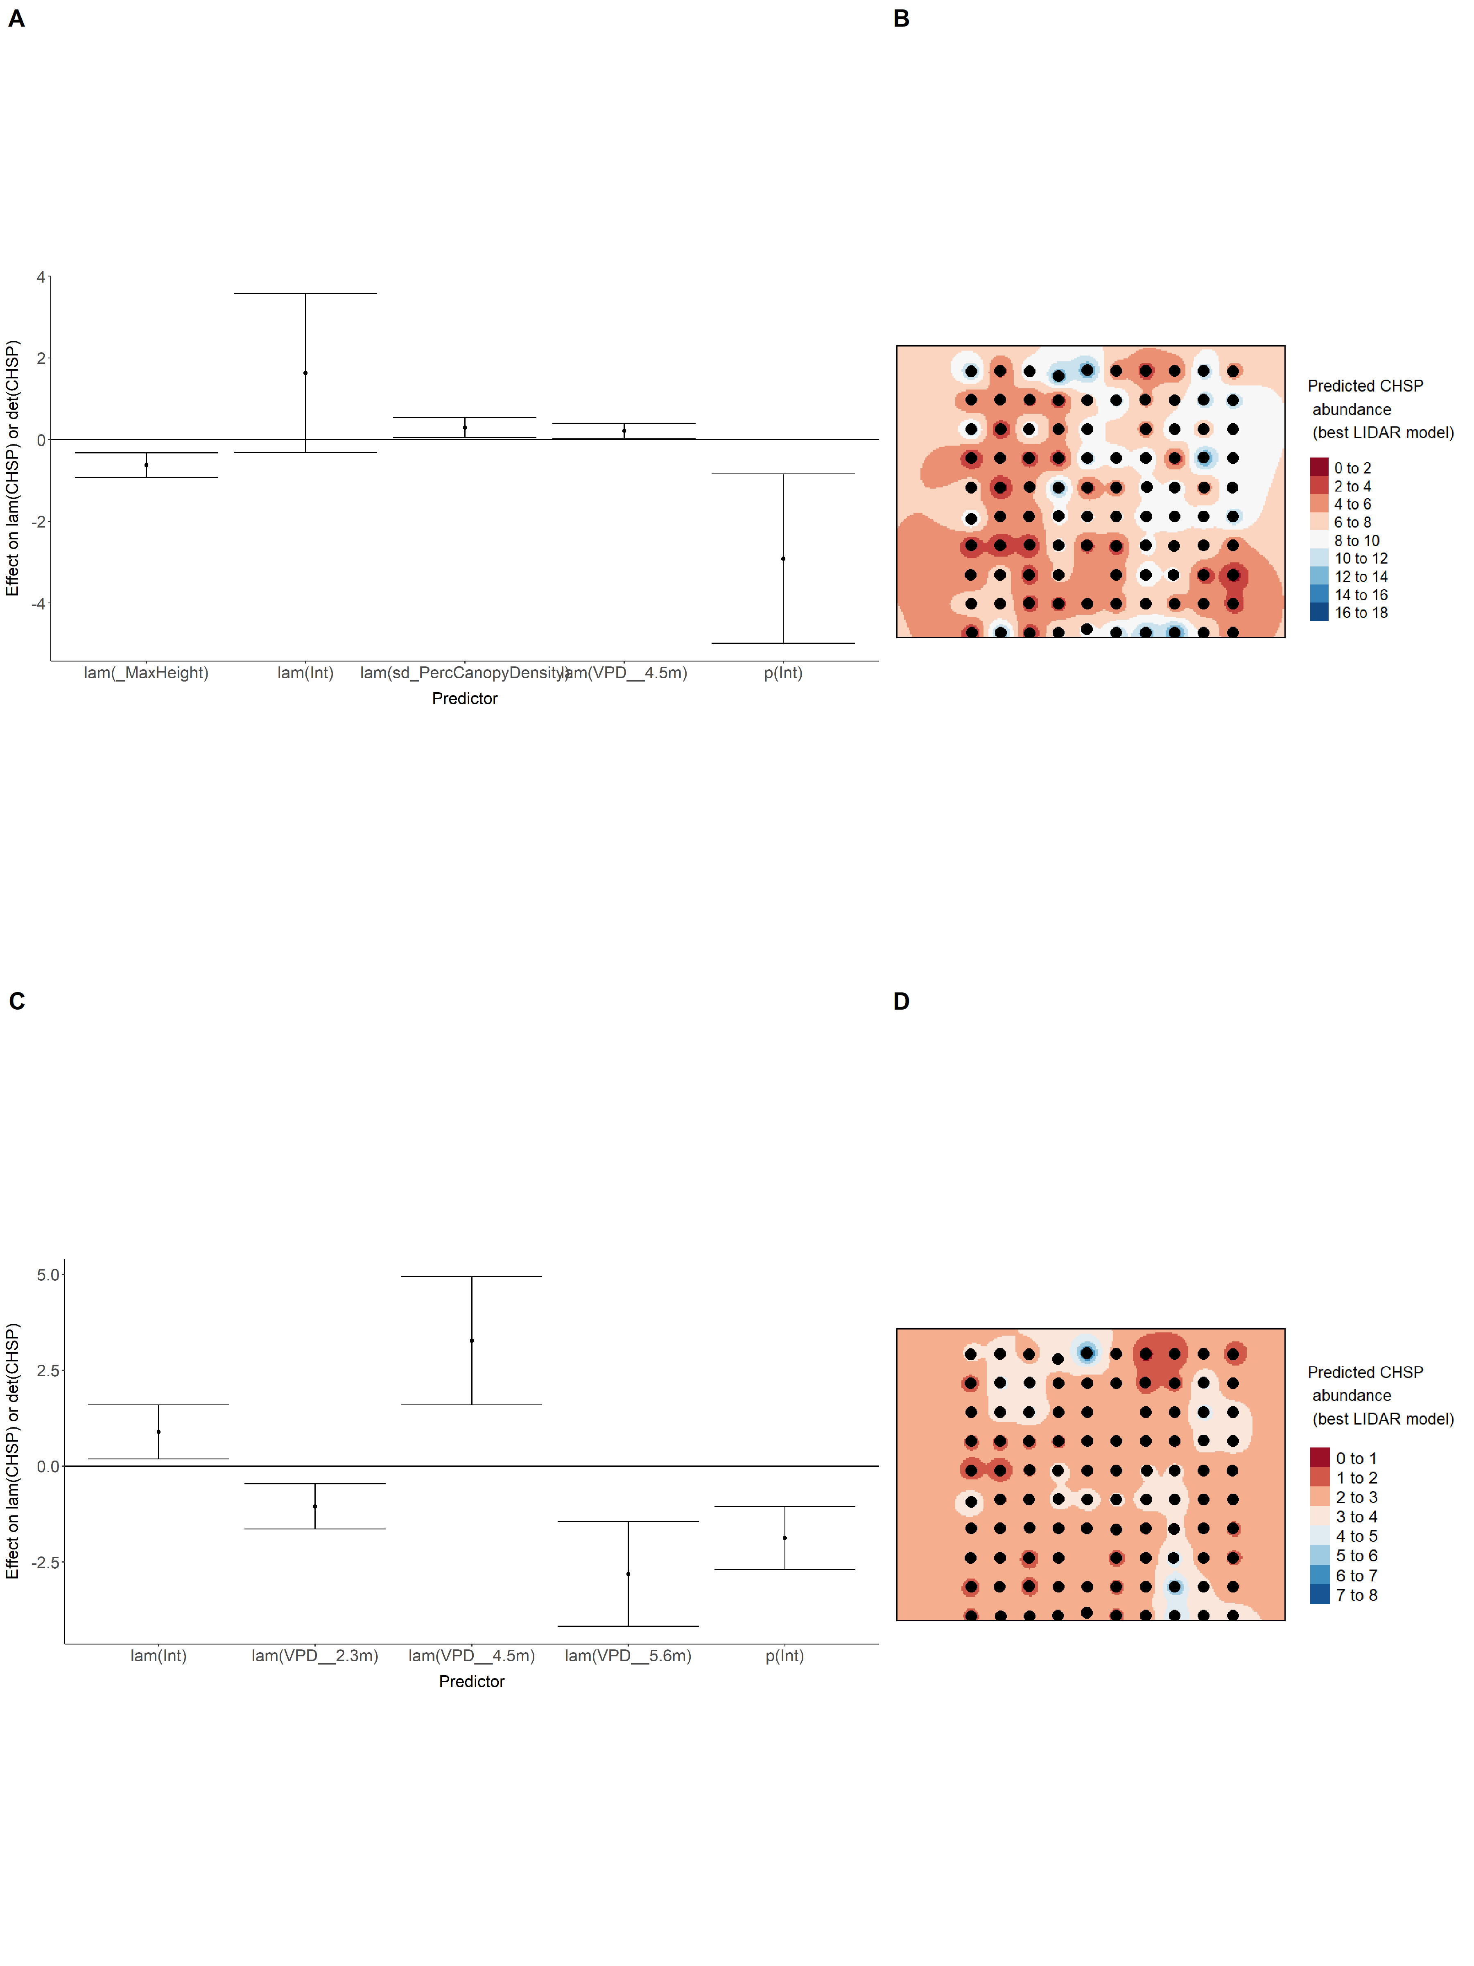

Model coefficients for the best *N*-mixture model predicting abundance of Common Yellowthroat *Geothlypis trichas* from LIDAR-based data at the 150-m scale (AIC= 113.58) (A), and 500-m scale (AIC= 114.43) (B), along with predicted abundances of this species in the Kirby grid from these respective models (C-D).

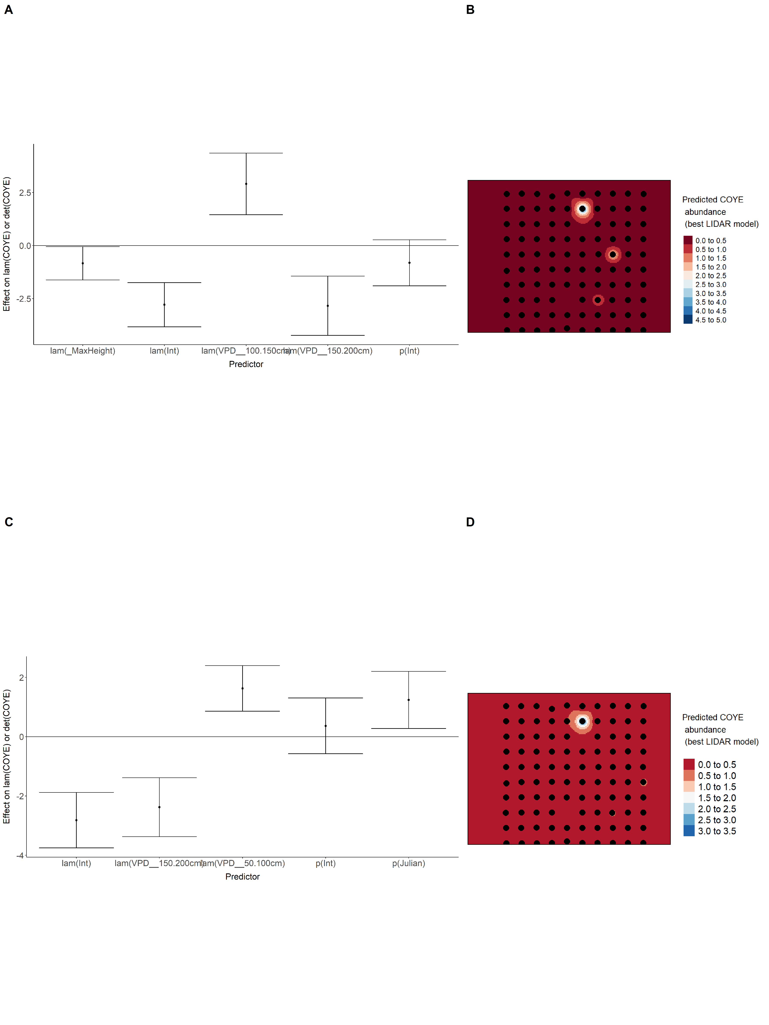

Model coefficients for the best *N*-mixture model predicting abundance of Dark-eyed Junco *Junco hyemalis* from LIDAR-based data at the 150-m scale (AIC= 422.02) (A), and 500-m scale (AIC= 430.56) (B), along with predicted abundances of this species in the Kirby grid from these respective models (C-D).

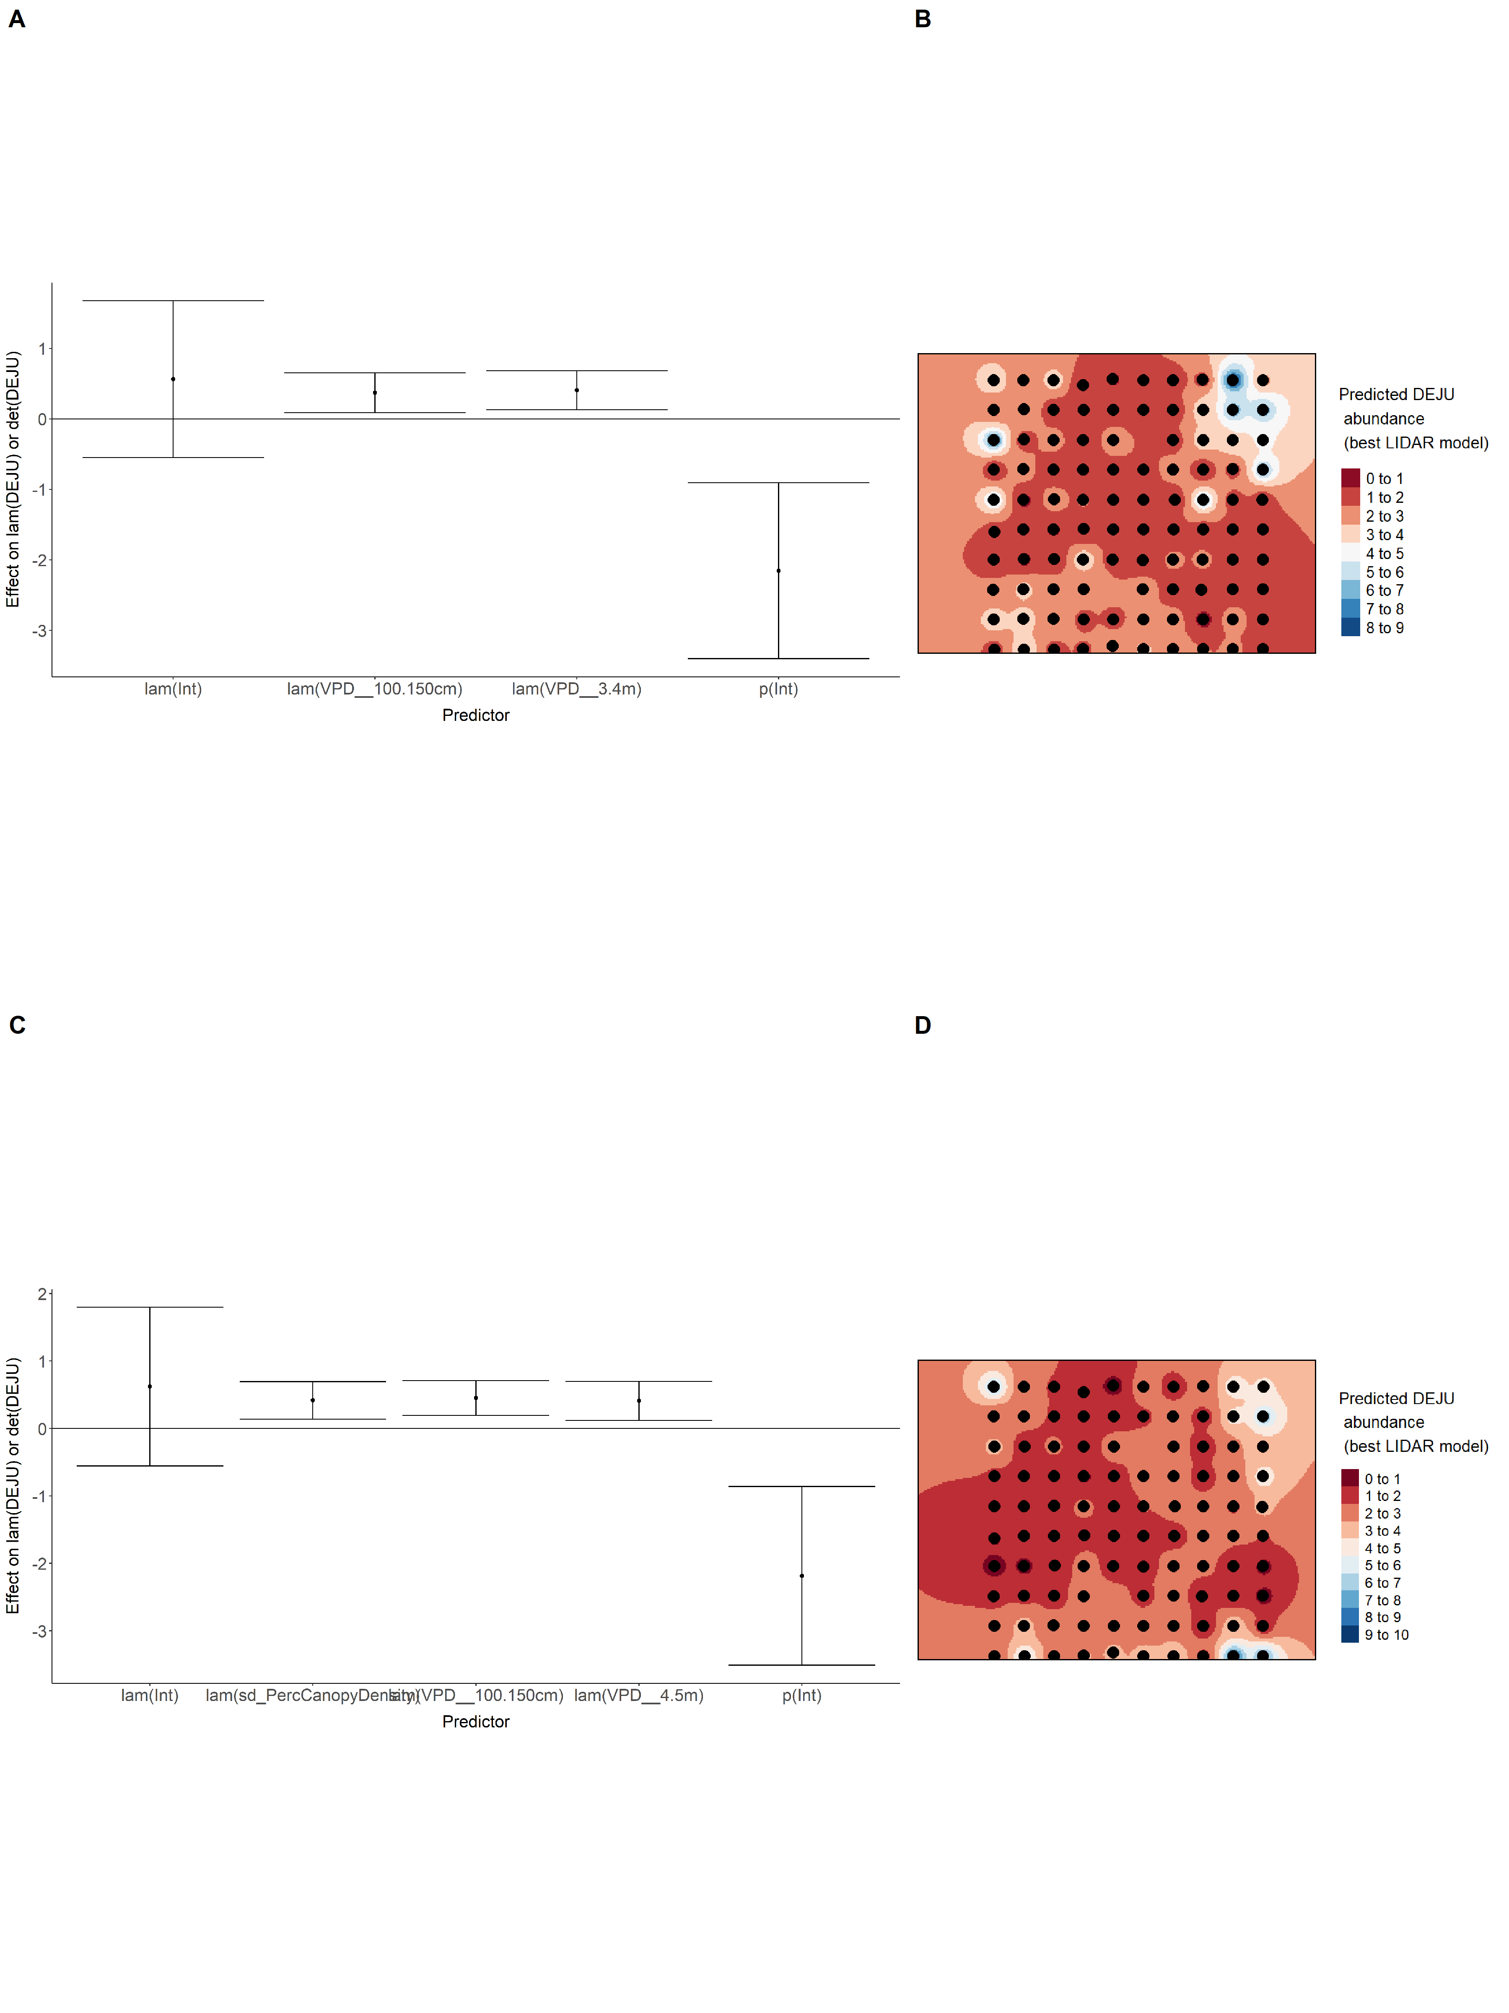

Model coefficients for the best *N*-mixture model predicting abundance of Gray Jay *Perisoreus canadensis* from LIDAR-based data at the 150-m scale (AIC= 465.27) (A), and 500-m scale (AIC= 461.19) (B), along with predicted abundances of this species in the Kirby grid from these respective models (C-D).

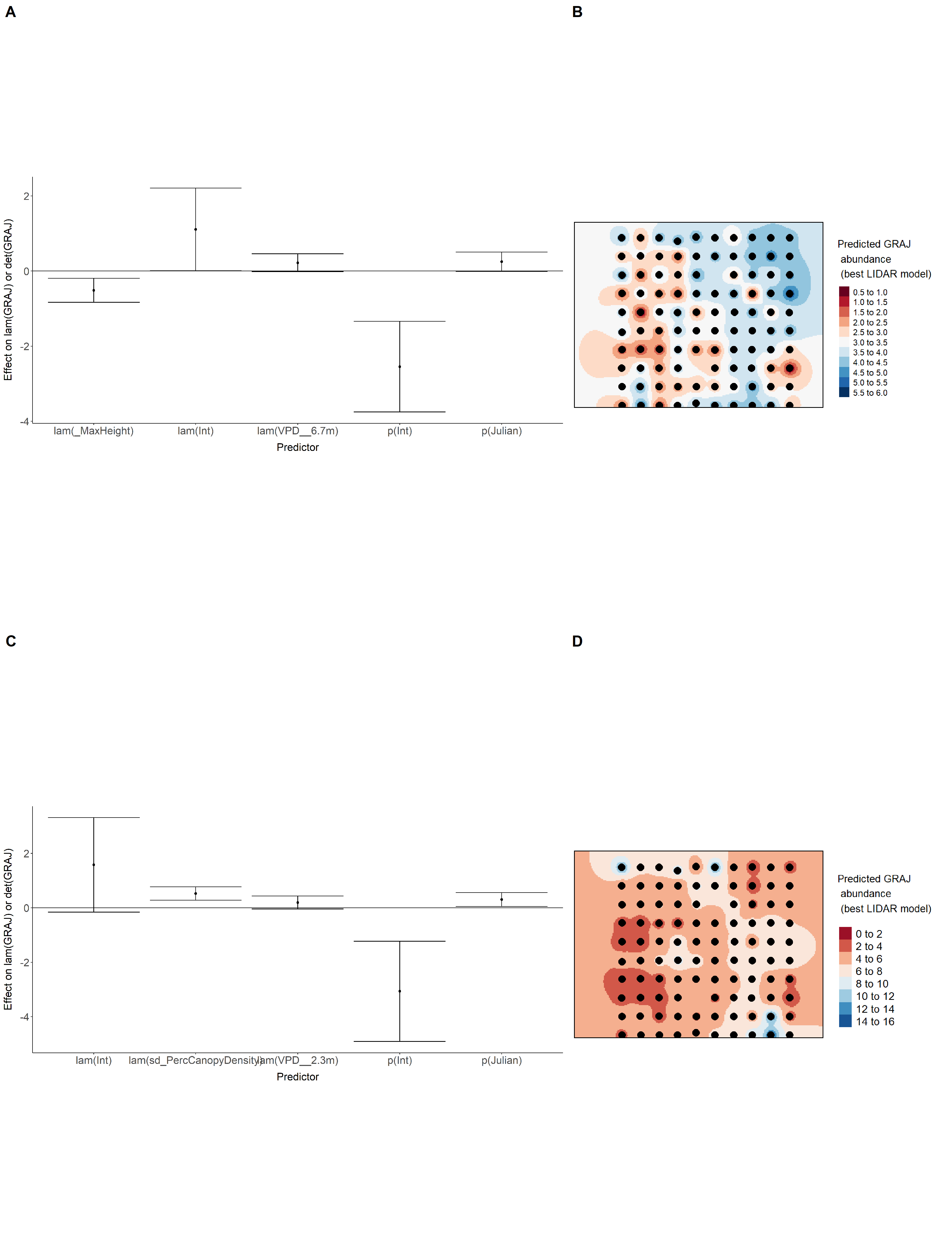

Model coefficients for the best *N*-mixture model predicting abundance of Hermit Thrush *Catharus guttatus* from LIDAR-based data at the 150-m scale (AIC= 679.97) (A), and 500-m scale (AIC= 676.18) (B), along with predicted abundances of this species in the Kirby grid from these respective models (C-D).

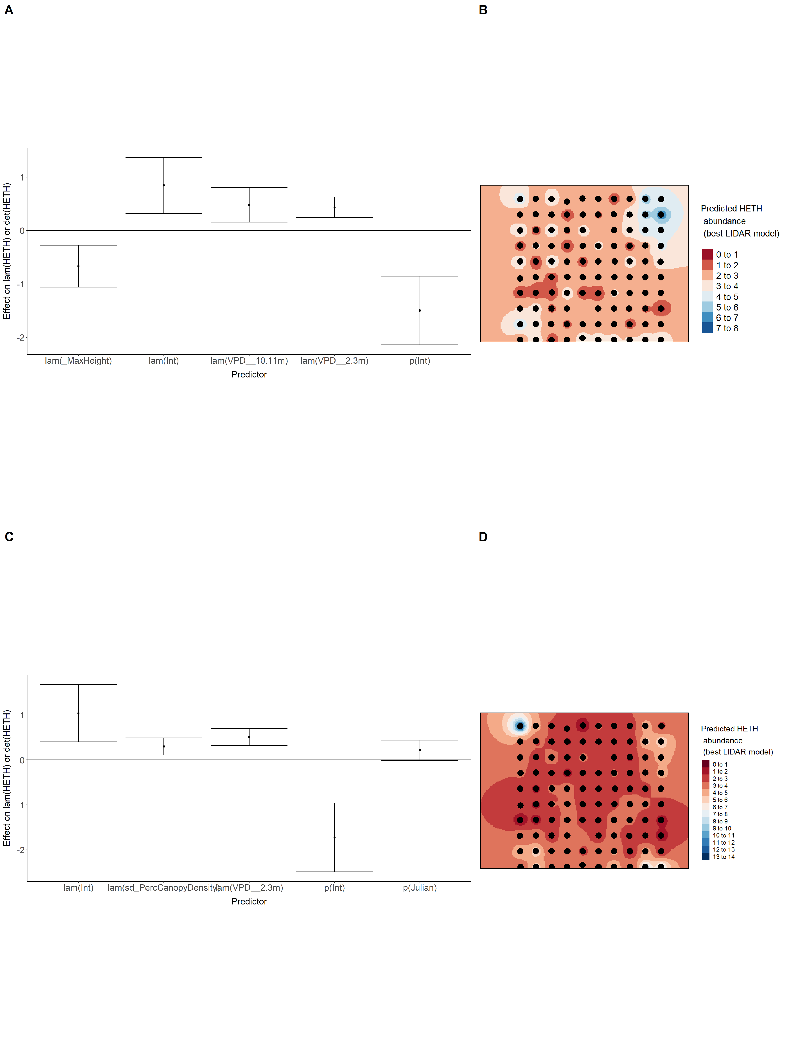

Model coefficients for the best *N*-mixture model predicting abundance of Le Conte’s Sparrow *Ammodramus lecontei* from LIDAR-based data at the 150-m scale (AIC= 227.99) (A), and 500-m scale (AIC= 245.87) (B), along with predicted abundances of this species in the Kirby grid from these respective models (C-D).

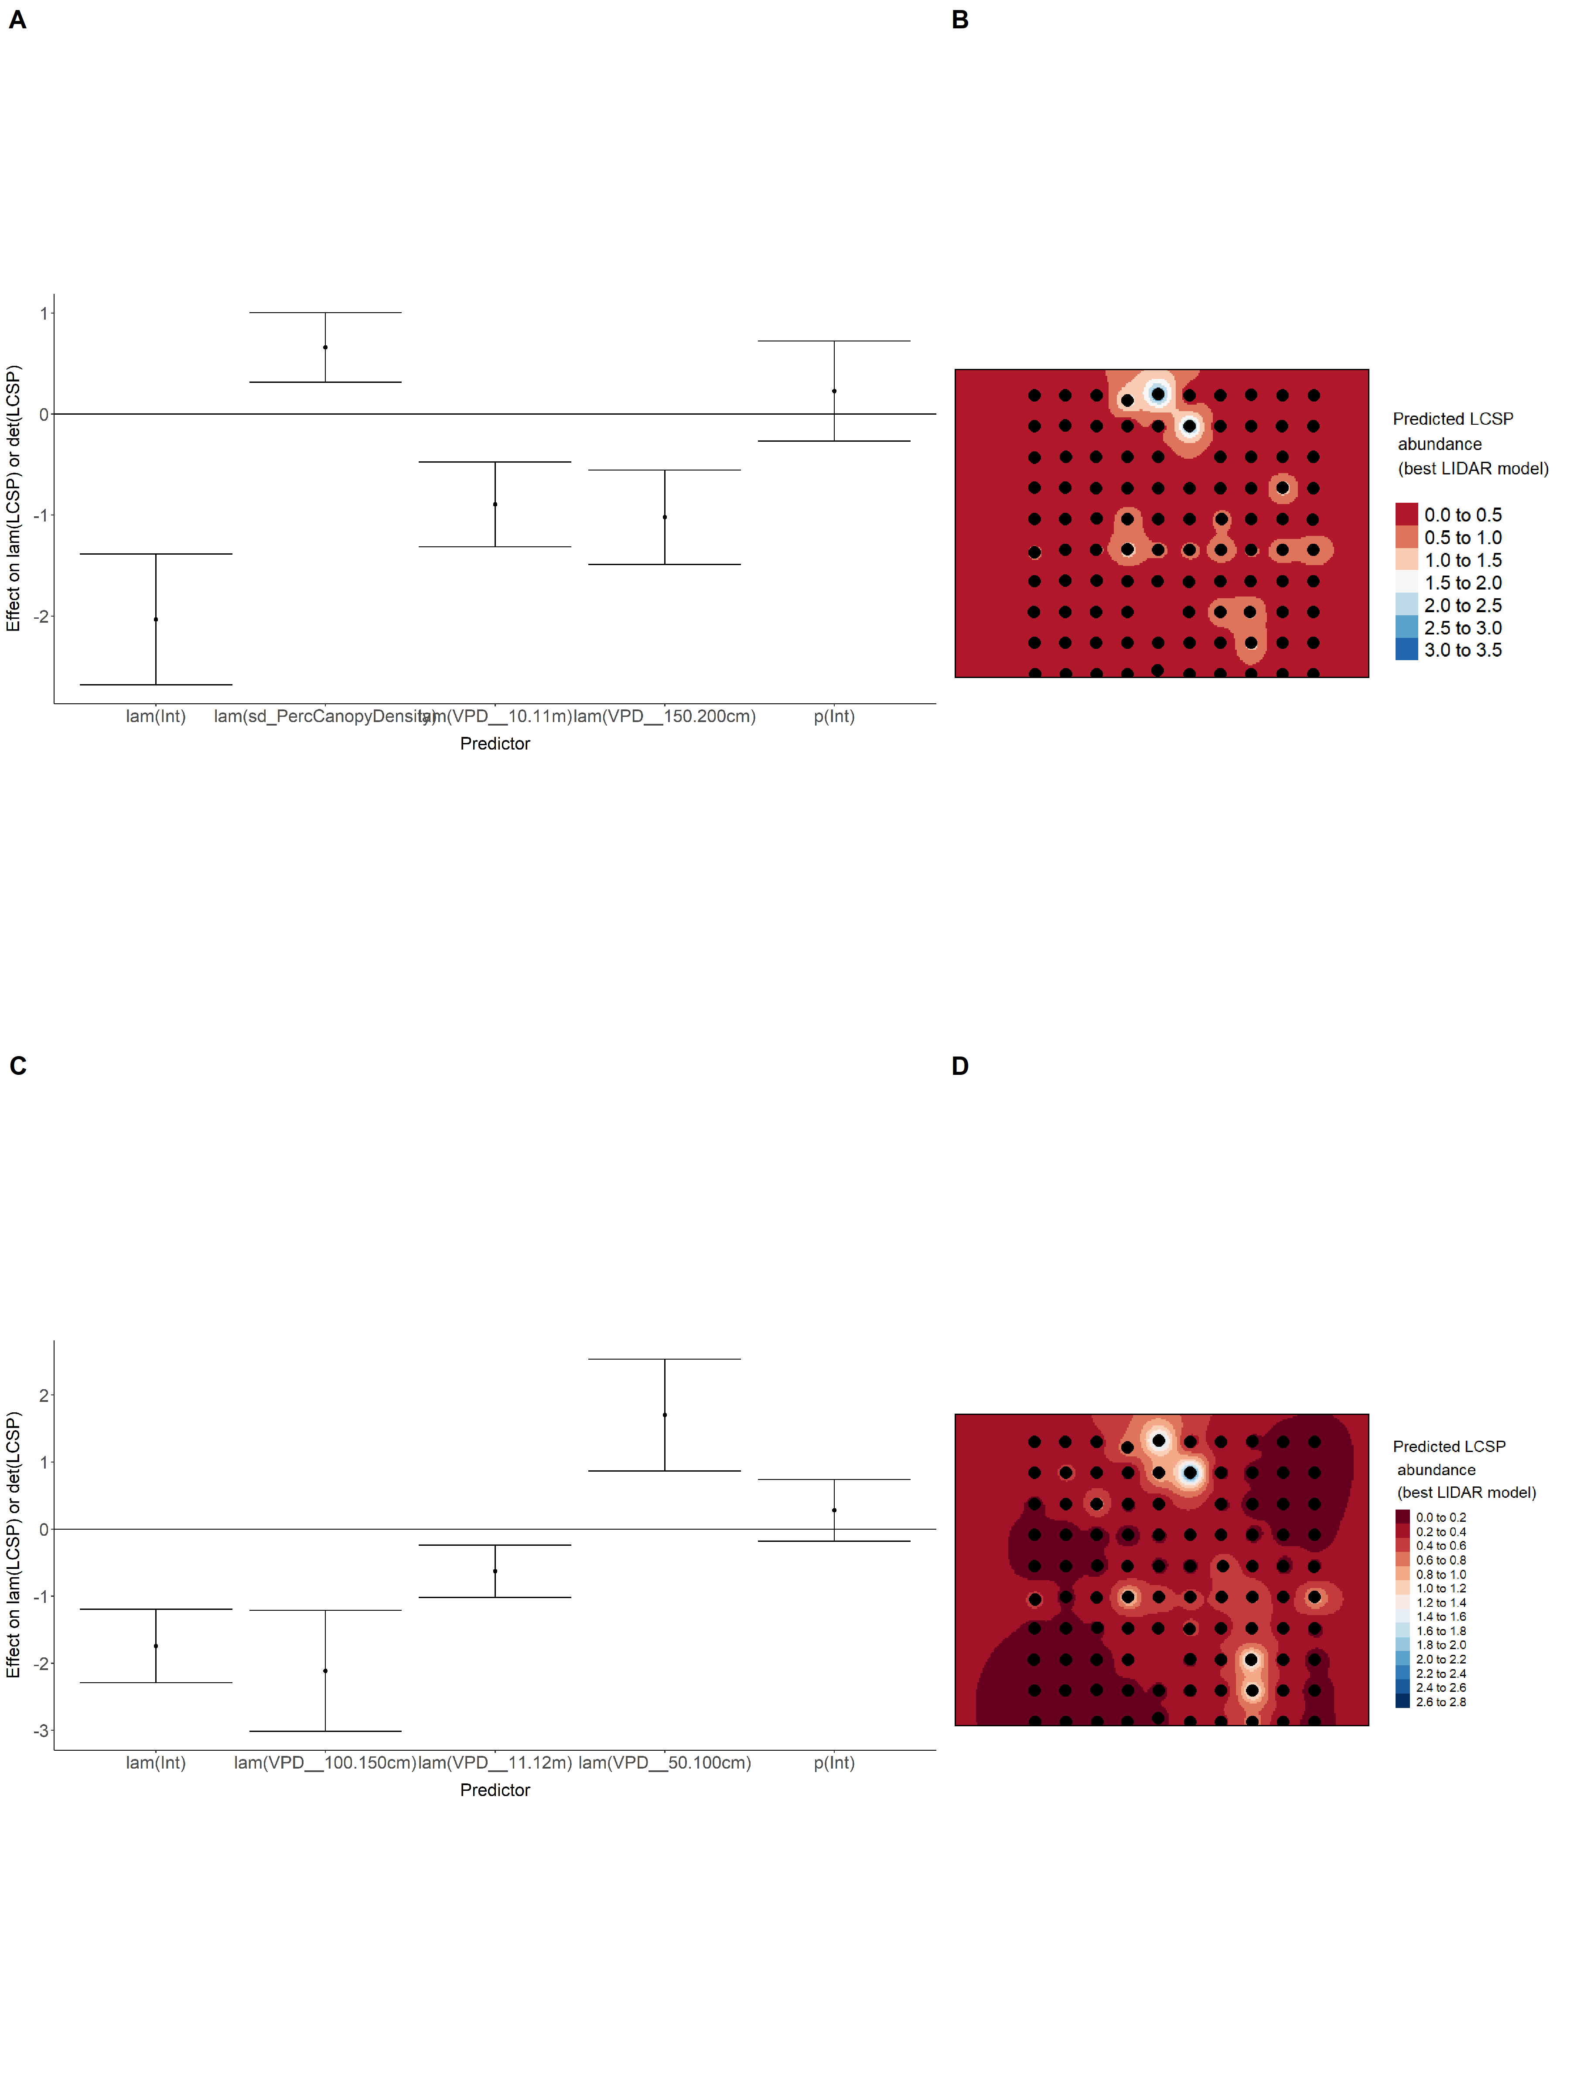

Model coefficients for the best *N*-mixture model predicting abundance of Lincoln’s Sparrow *Melospiza lincolnii* from LIDAR-based data at the 150-m scale (AIC= 439.74) (A), and 500-m scale (AIC= 470.87) (B), along with predicted abundances of this species in the Kirby grid from these respective models (C-D).

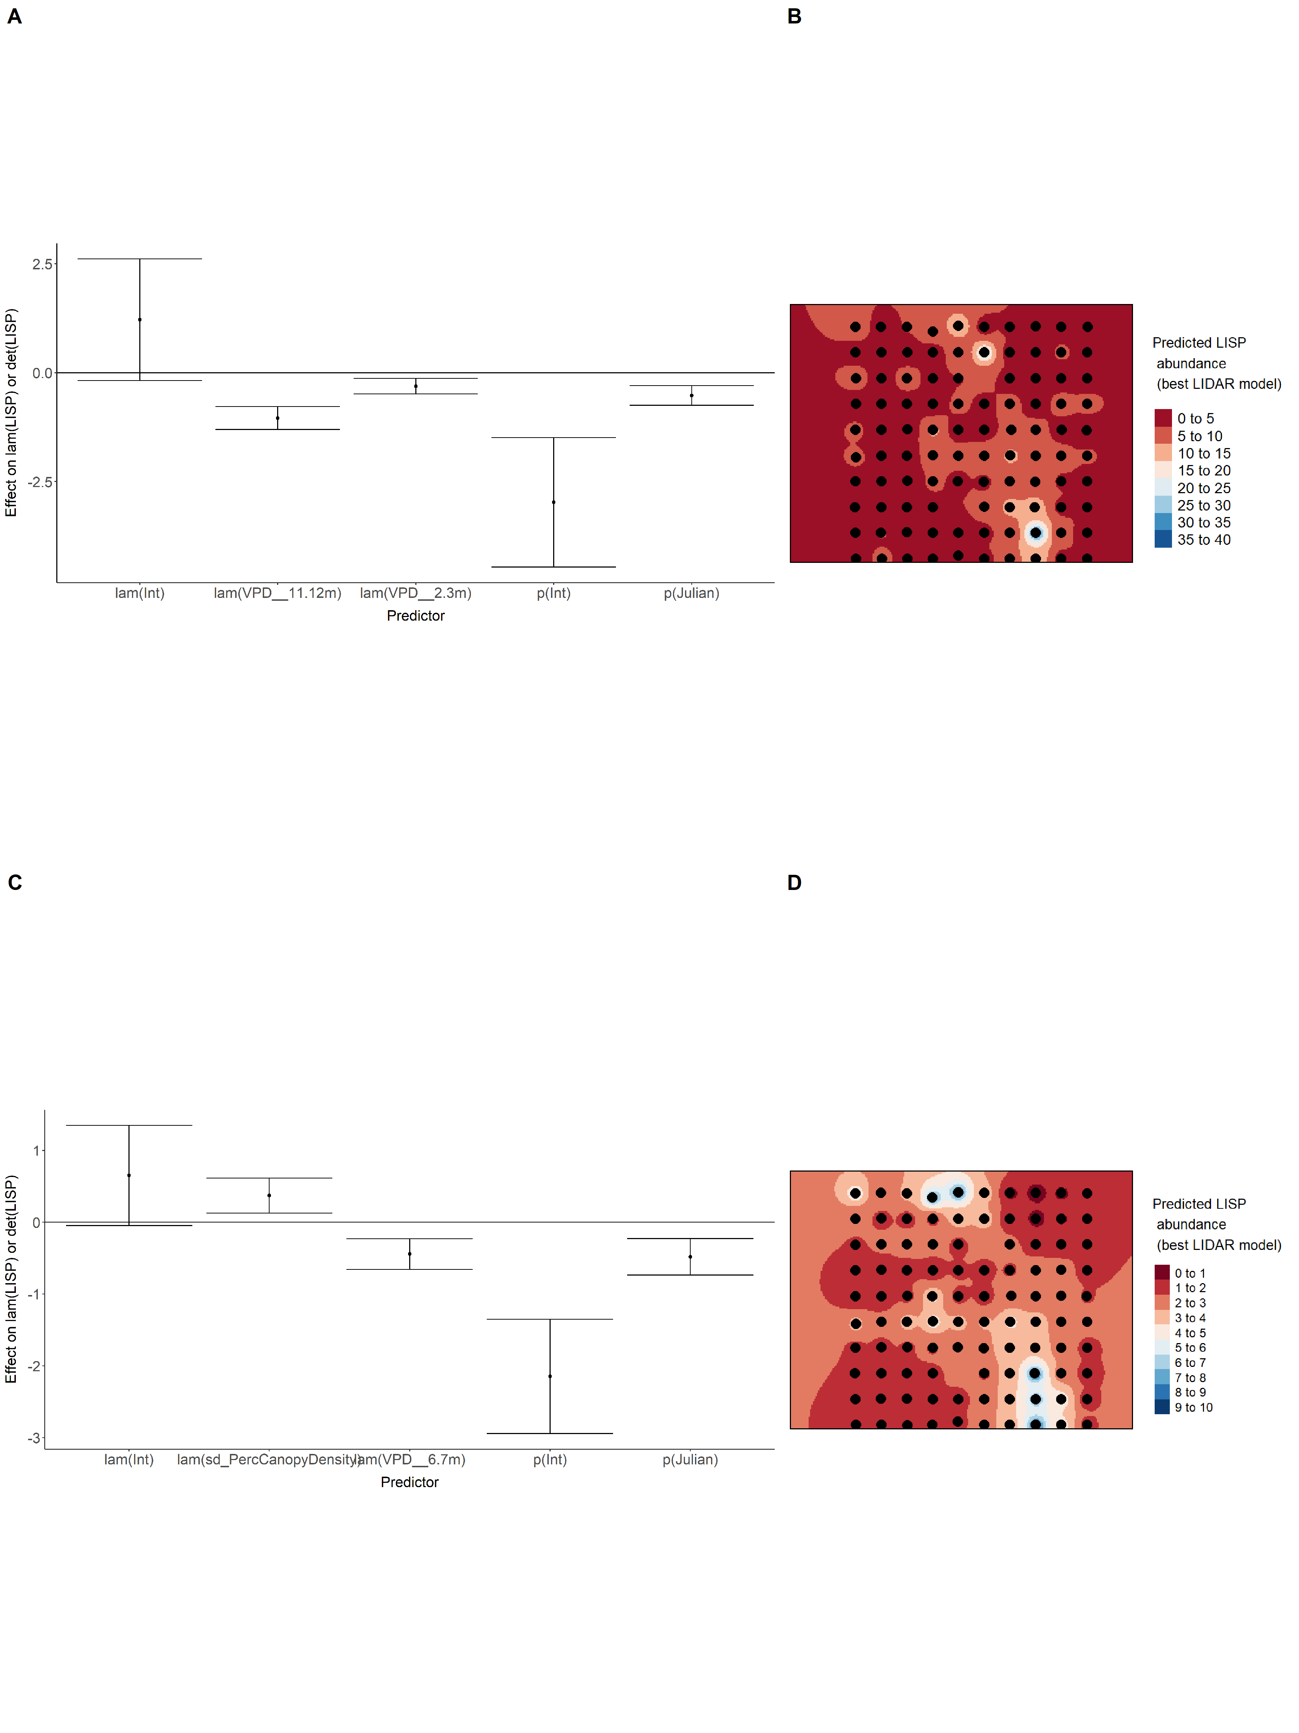

Model coefficients for the best *N*-mixture model predicting abundance of Olive-sided Flycatcher *Contopus cooperi* from LIDAR-based data at the 150-m scale (AIC= 141.84) (A), and 500-m scale (AIC= 126.82) (B), along with predicted abundances of this species in the Kirby grid from these respective models (C-D).

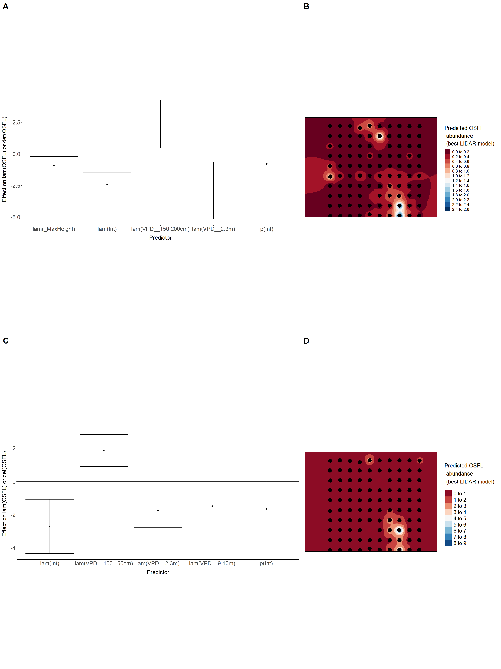

Model coefficients for the best *N*-mixture model predicting abundance of Ovenbird *Seiurus aurocapillus* from LIDAR-based data at the 150-m scale (AIC= 325.68) (A), and 500-m scale (AIC= 326.91) (B), along with predicted abundances of this species in the Kirby grid from these respective models (C-D).

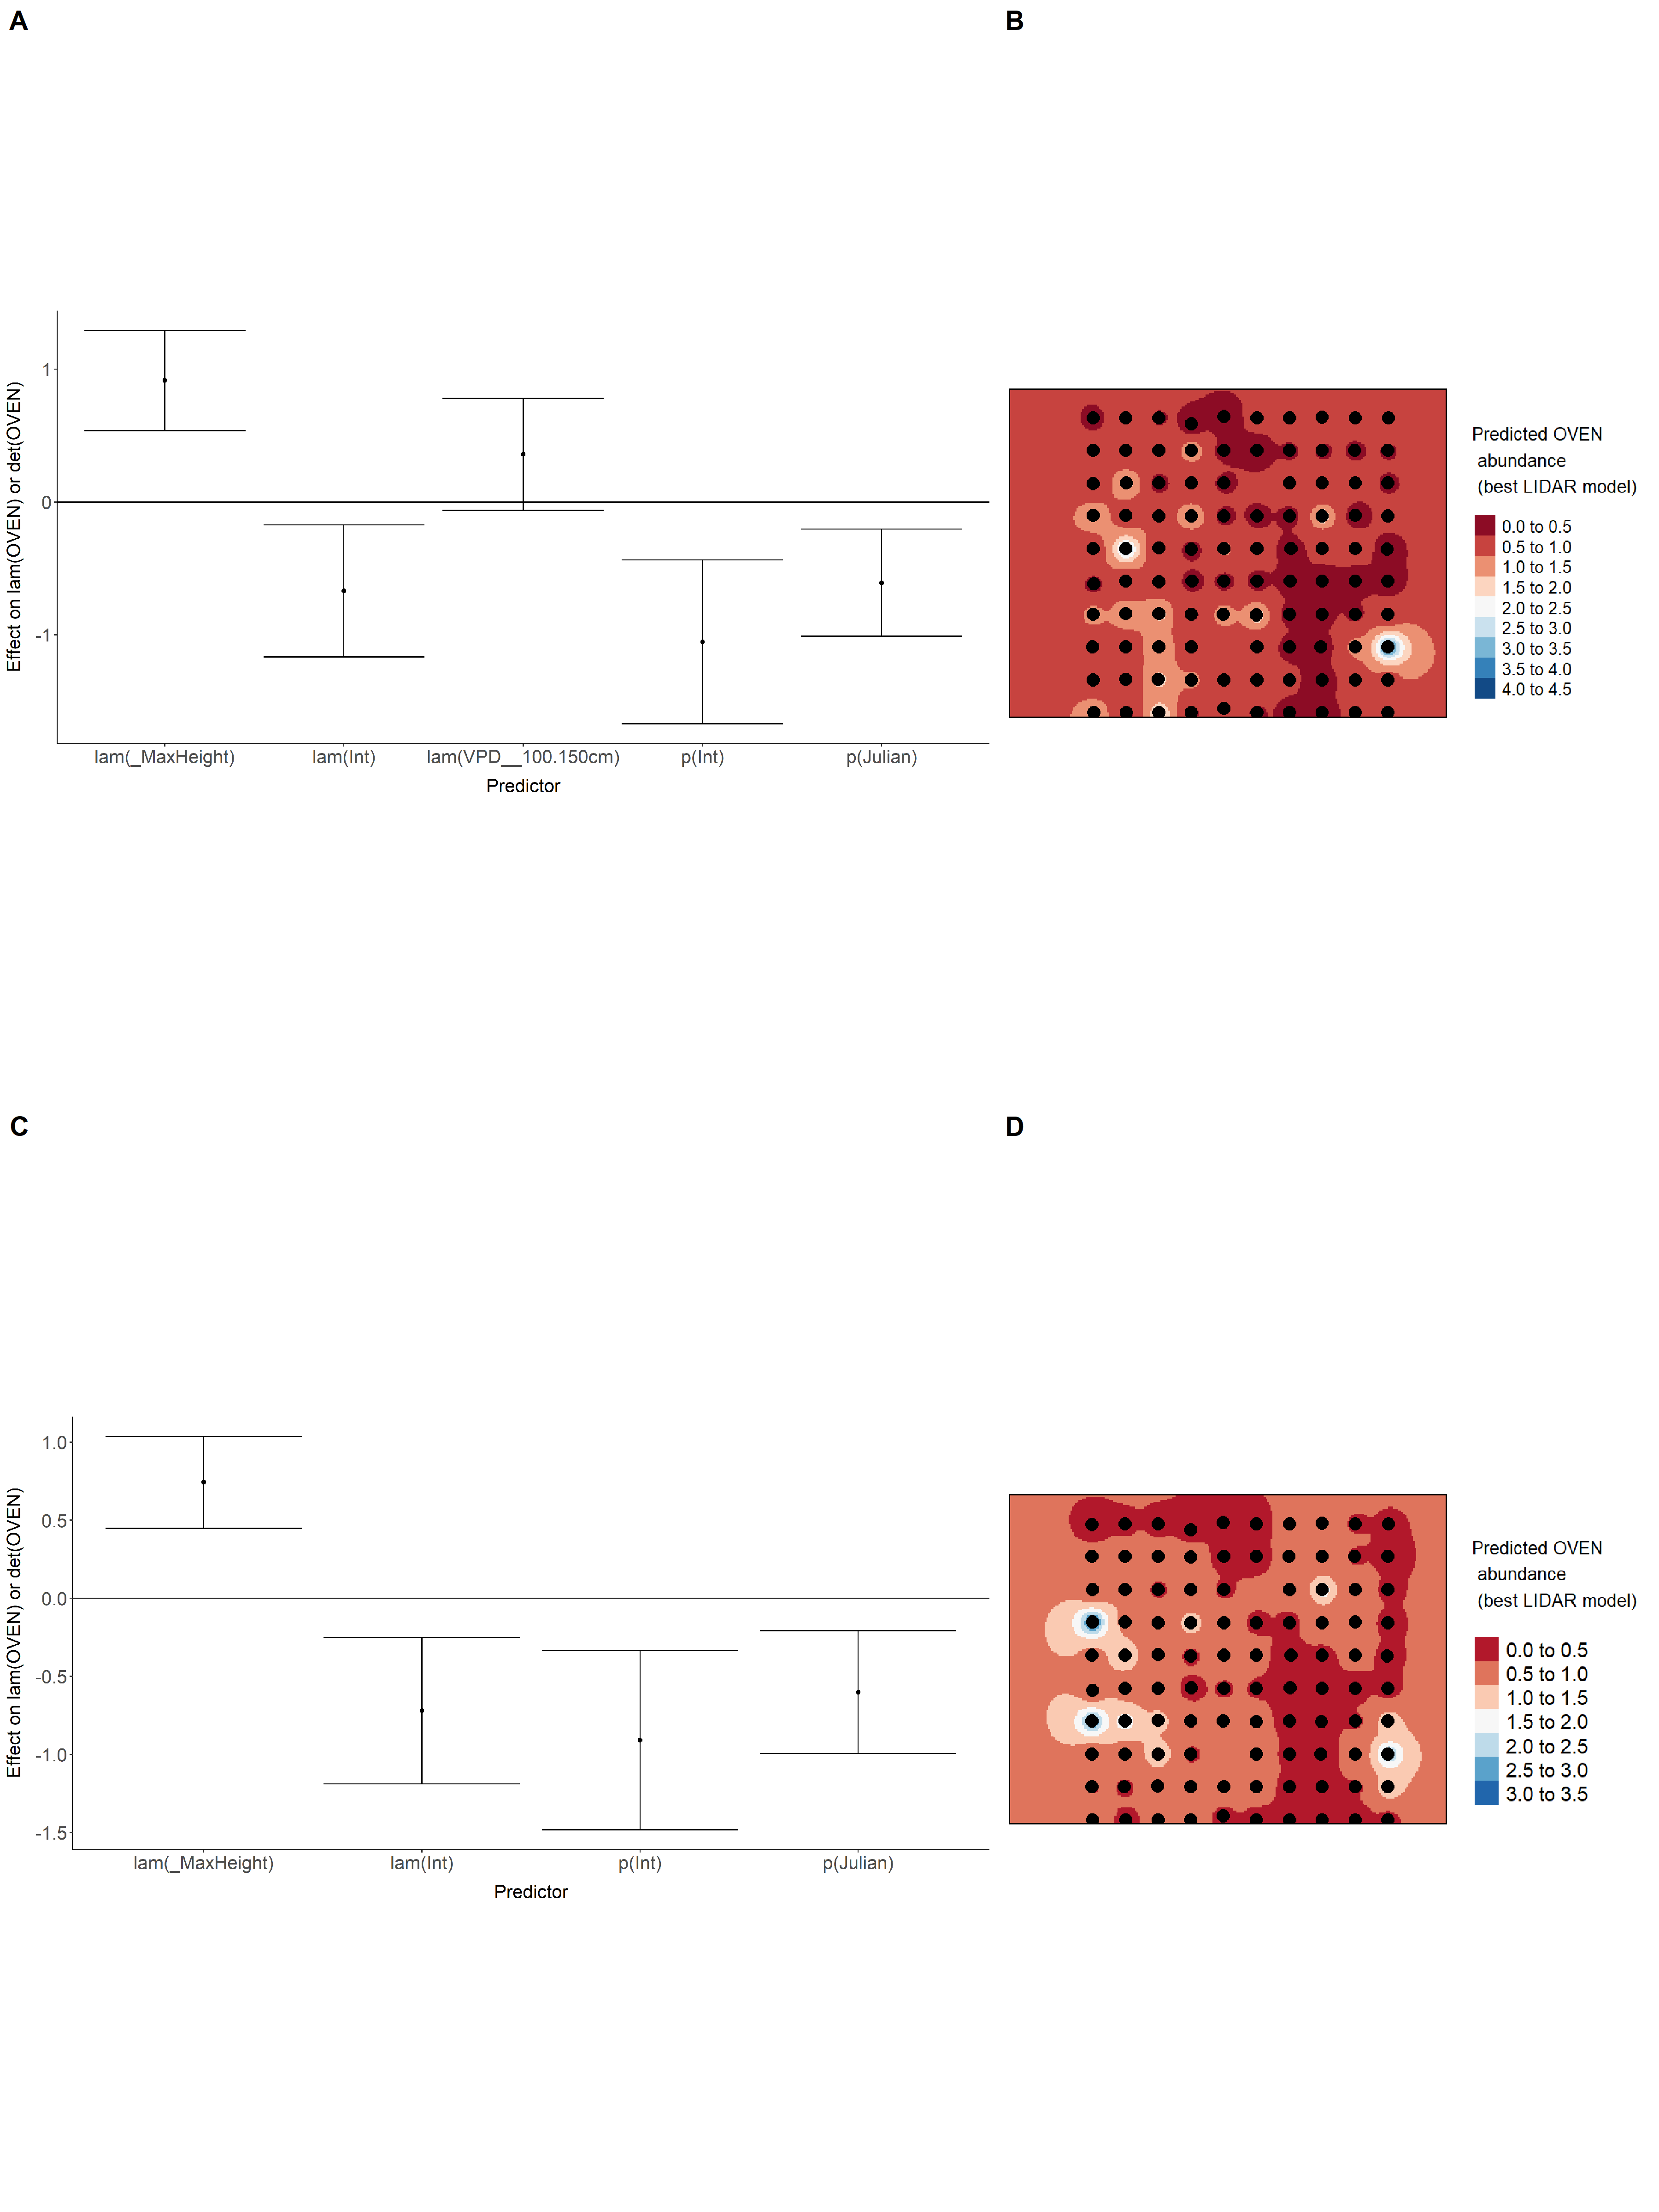

Model coefficients for the best *N*-mixture model predicting abundance of Palm Warbler *Setophaga palmarum* from LIDAR-based data at the 150-m scale (AIC= 159.23) (A), and 500-m scale (AIC= 156.91) (B), along with predicted abundances of this species in the Kirby grid from these respective models (C-D).

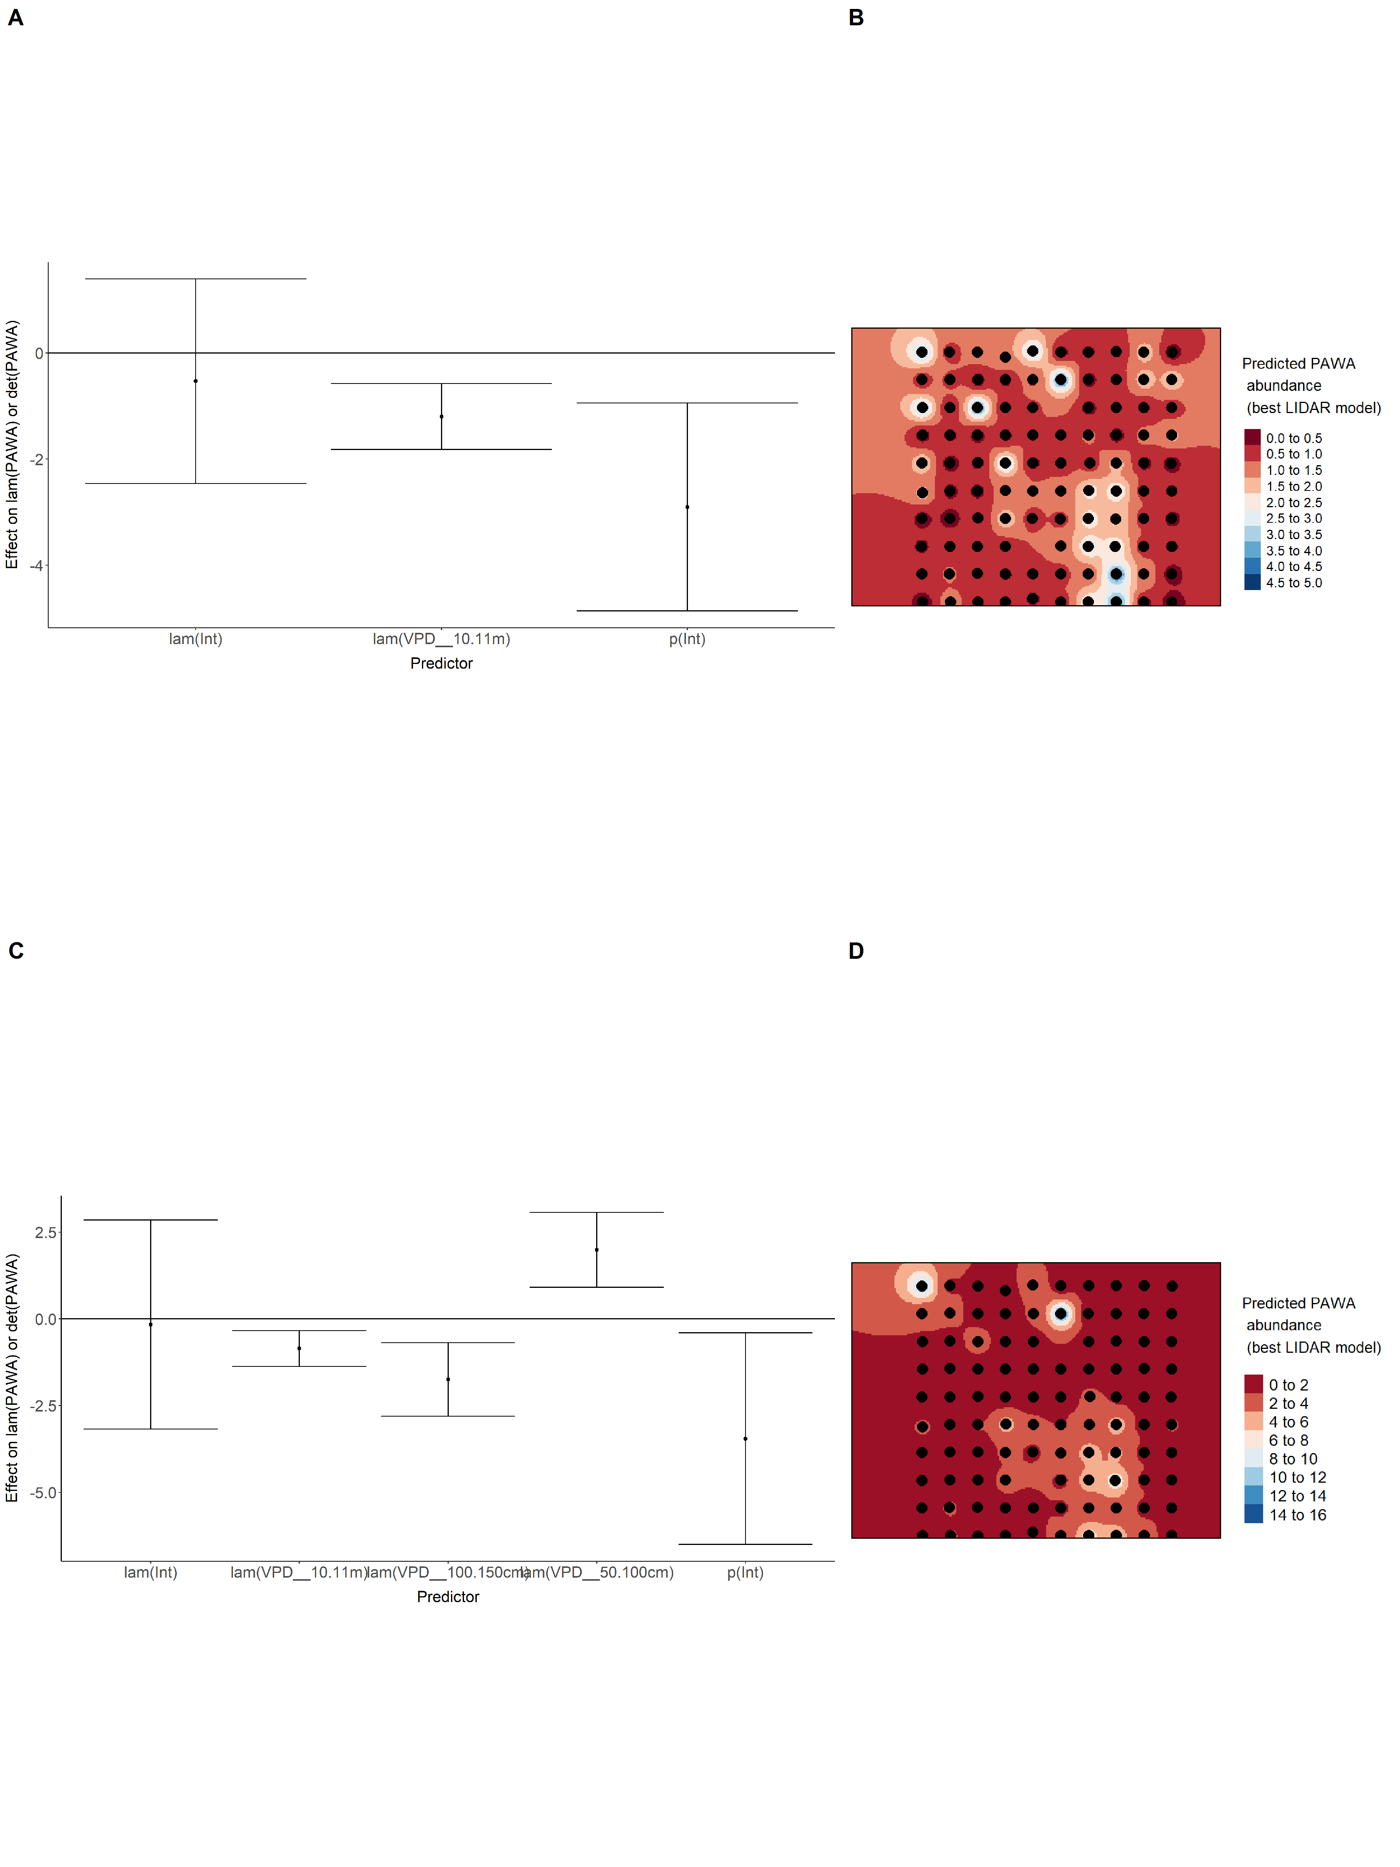

Model coefficients for the best *N*-mixture model predicting abundance of Red-eyed Vireo *Vireo olivaceus* from LIDAR-based data at the 150-m scale (AIC= 293.08) (A), and 500-m scale (AIC= 286.33) (B), along with predicted abundances of this species in the Kirby grid from these respective models (C-D).

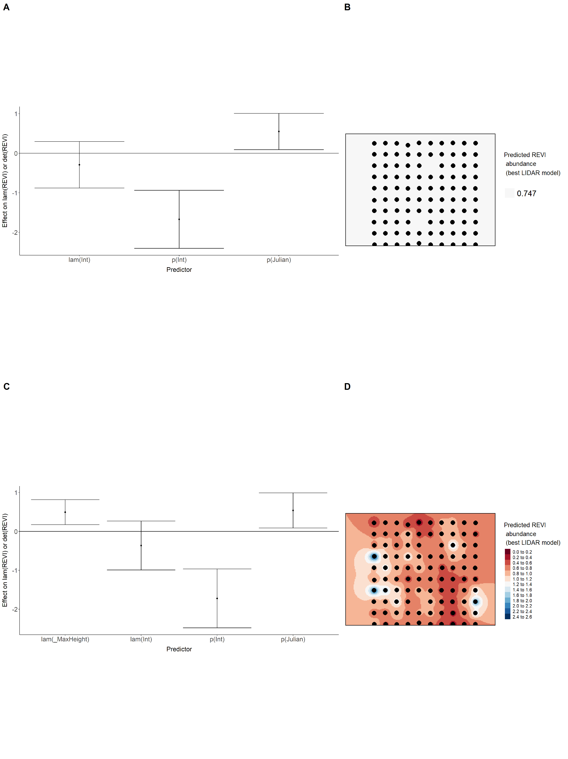

Model coefficients for the best *N*-mixture model predicting abundance of Ruby-crowned Kinglet *Regulus calendula* from LIDAR-based data at the 150-m scale (AIC= 355.53) (A), and 500-m scale (AIC= 357.95) (B), along with predicted abundances of this species in the Kirby grid from these respective models (C-D).

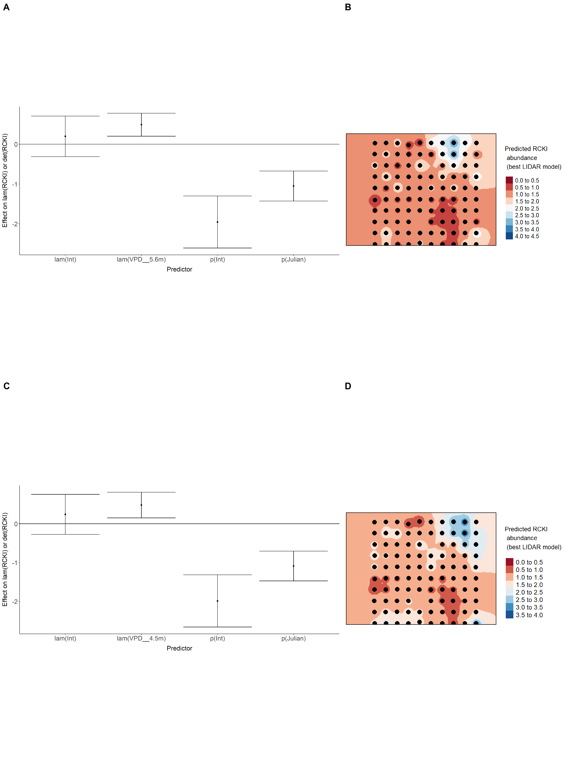

Model coefficients for the best *N*-mixture model predicting abundance of Swainson’s Thrush *Catharus ustulatus* from LIDAR-based data at the 150-m scale (AIC= 665.47) (A), and 500-m scale (AIC= 660.96) (B), along with predicted abundances of this species in the Kirby grid from these respective models (C-D).

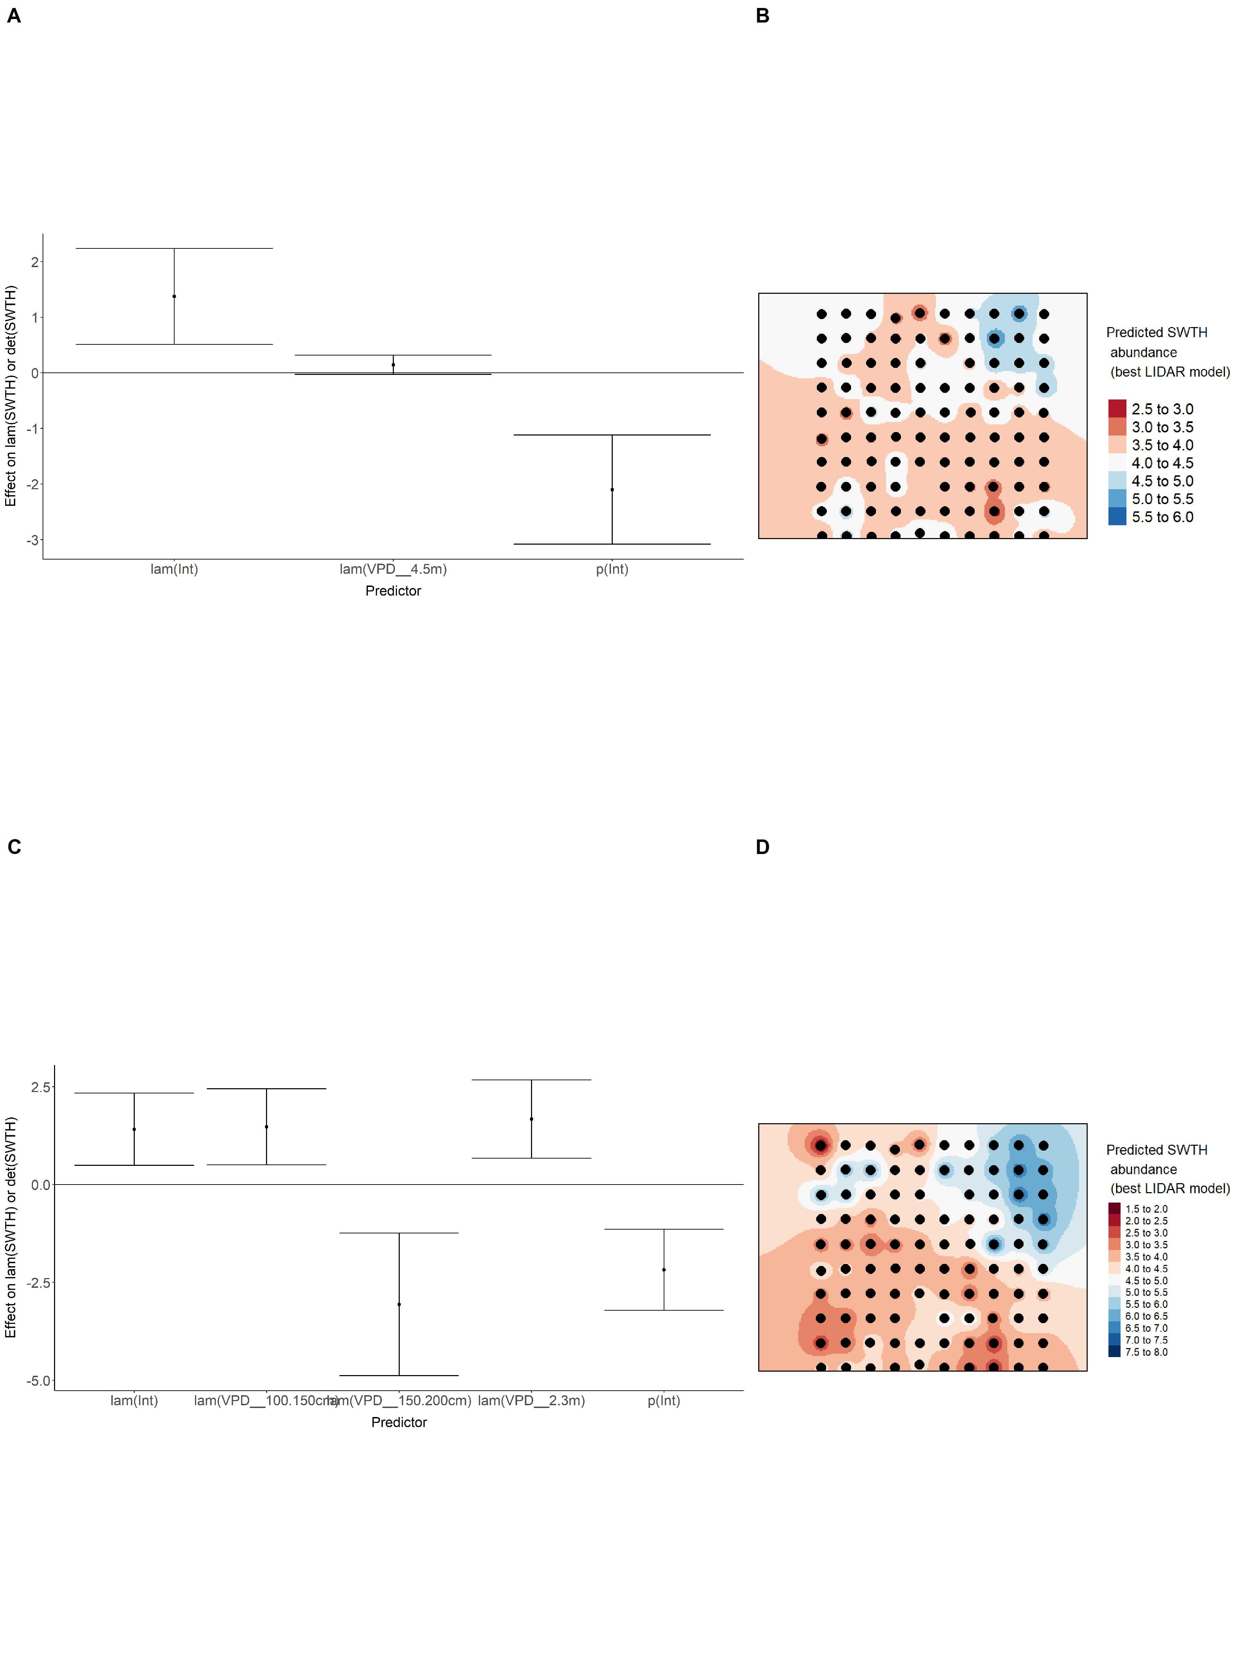

Model coefficients for the best *N*-mixture model predicting abundance of Swamp Sparrow *Melospiza georgiana* from LIDAR-based data at the 150-m scale (AIC= 138.15) (A), 500-m scale (AIC= 143.69) (B), along with predicted abundances of this species in the Kirby grid from these respective models (C-D).

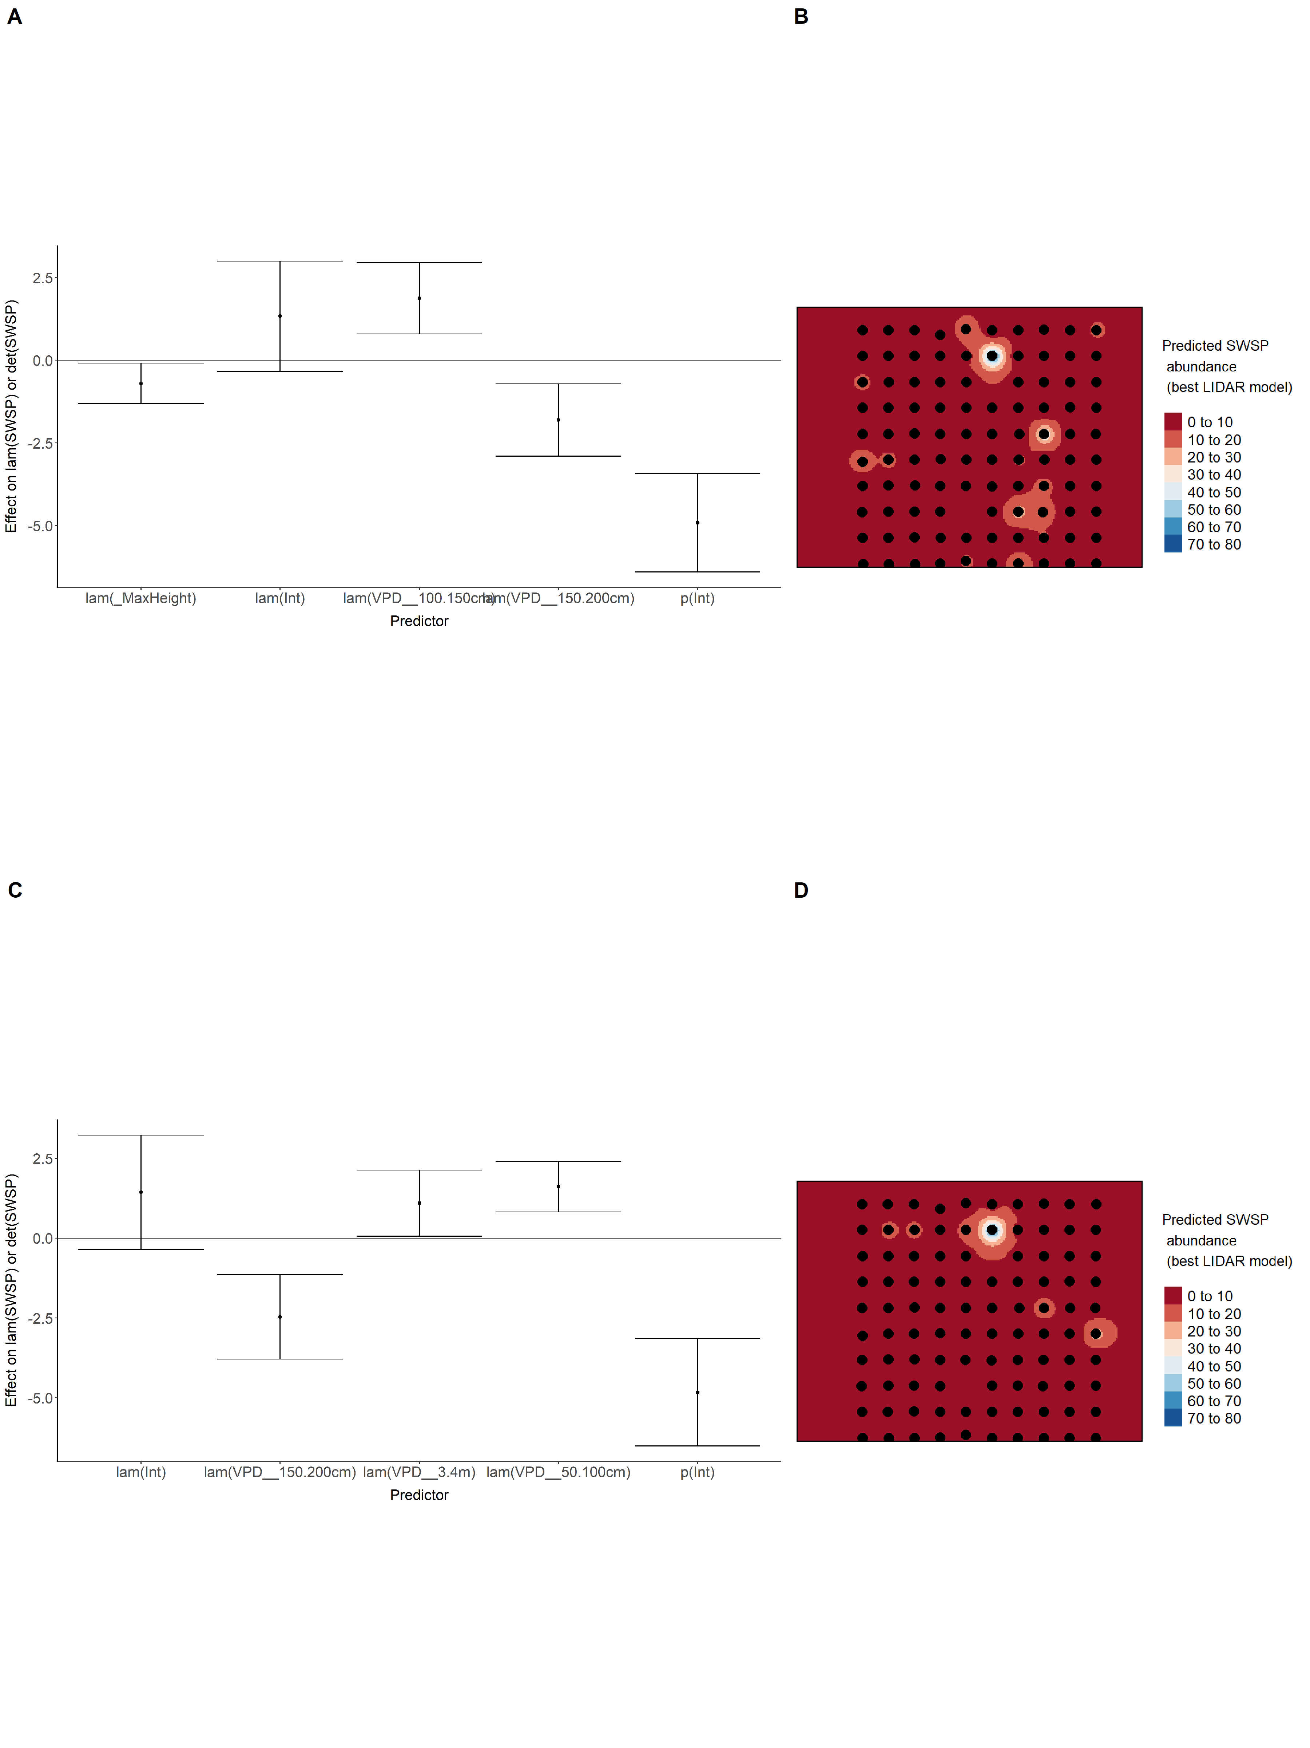

Model coefficients for the best *N*-mixture model predicting abundance of Tennessee Warbler *Leiothlypis peregrina* from LIDAR-based data at the 150-m scale (AIC= 322.38) (A), and 500-m scale (AIC= 328.8) (B), along with predicted abundances of this species in the Kirby grid from these respective models (C-D).

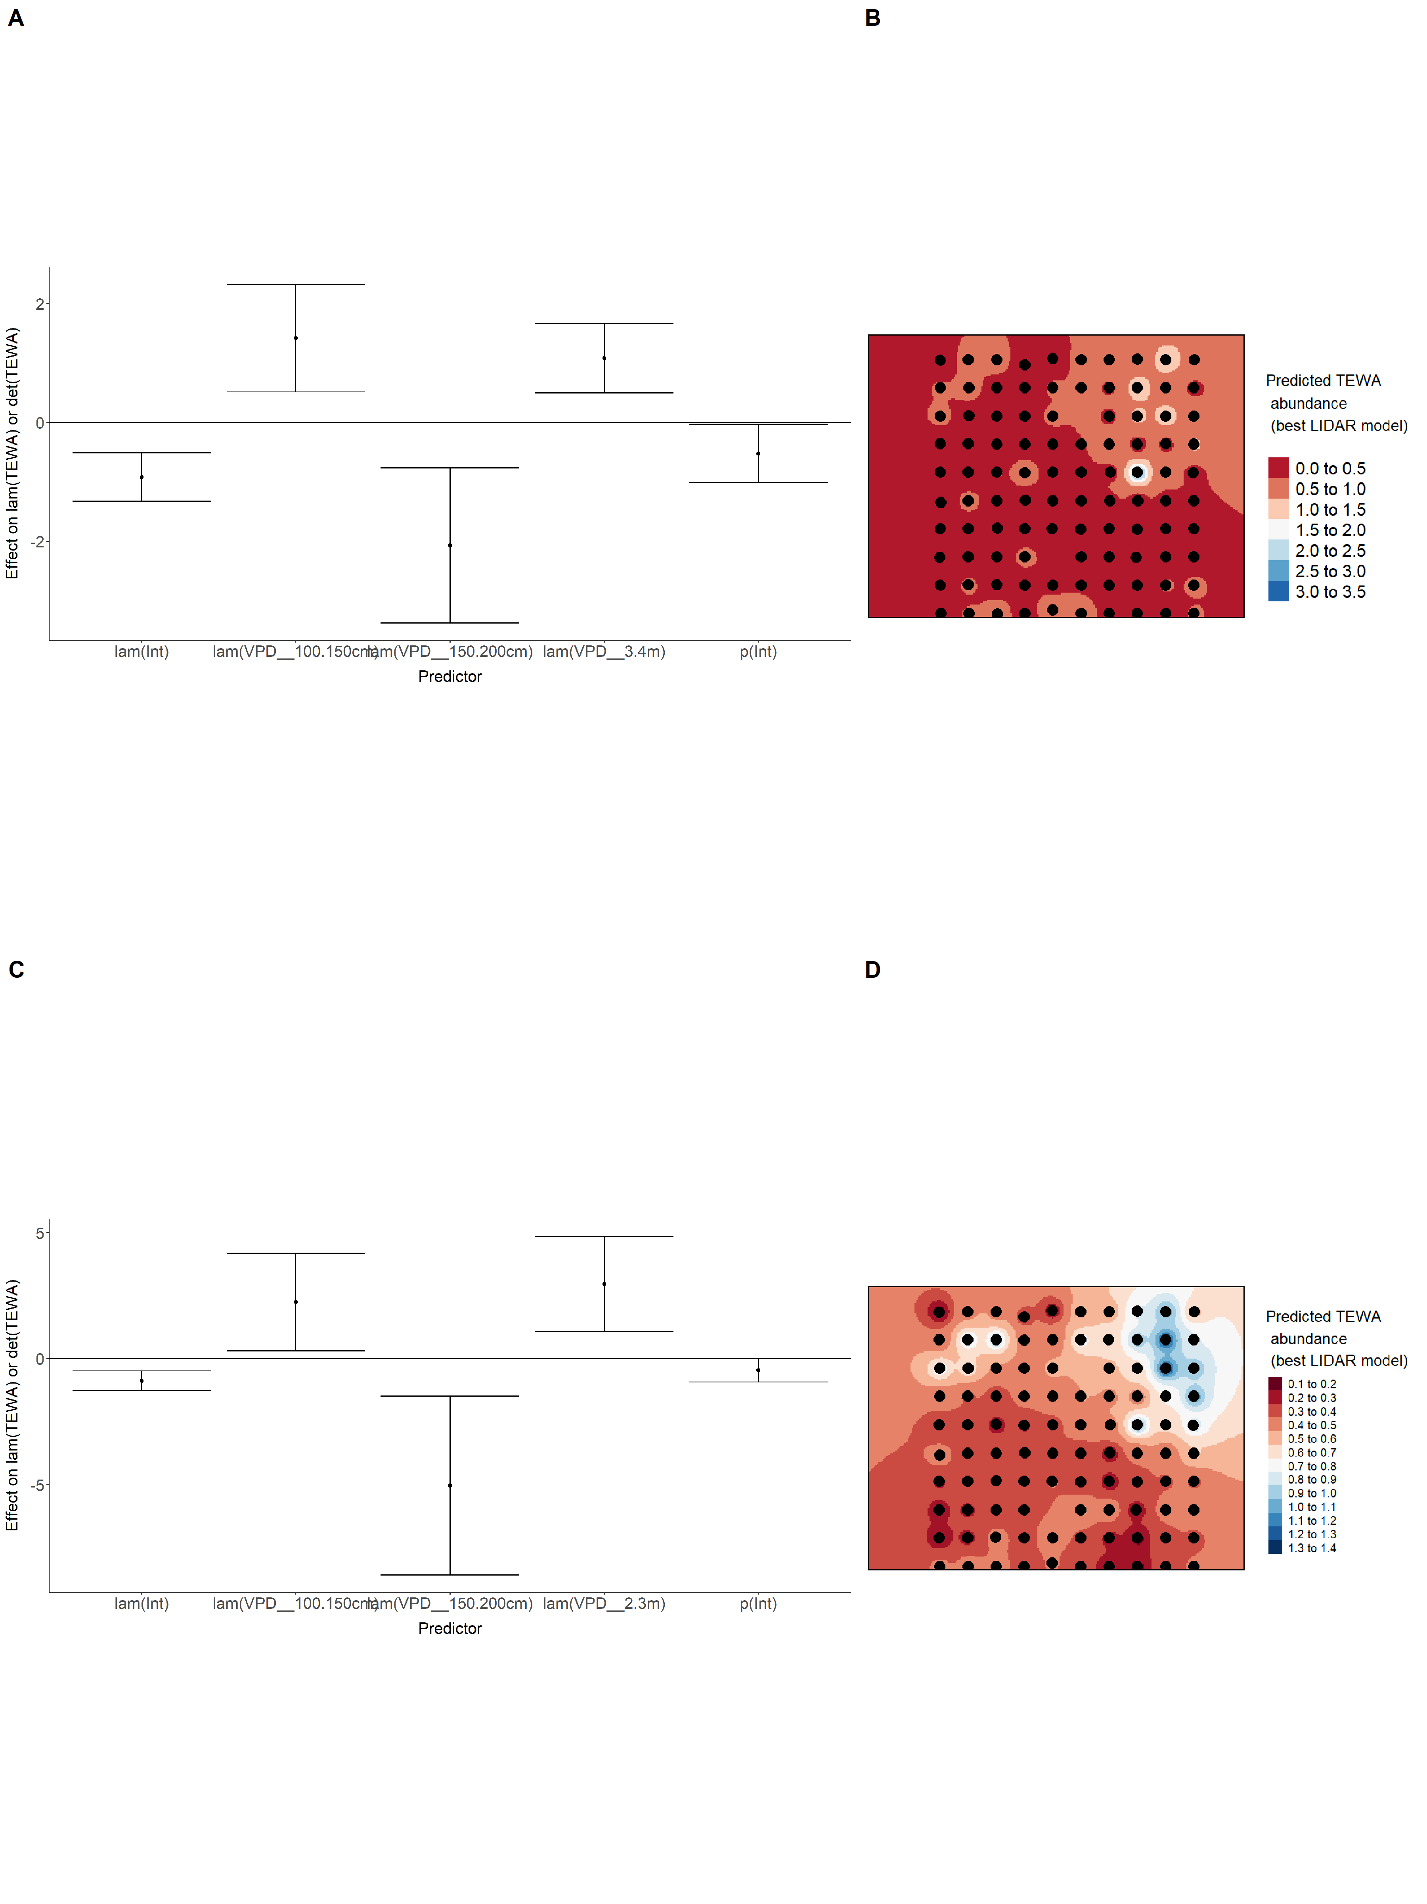

Model coefficients for the best *N*-mixture model predicting abundance of Winter Wren *Troglodytes hiemalis* from LIDAR-based data at the 150-m scale (AIC= 272.69) (A), and 500-m scale (AIC= 259.32) (B), along with predicted abundances of this species in the Kirby grid from these respective models (C-D).

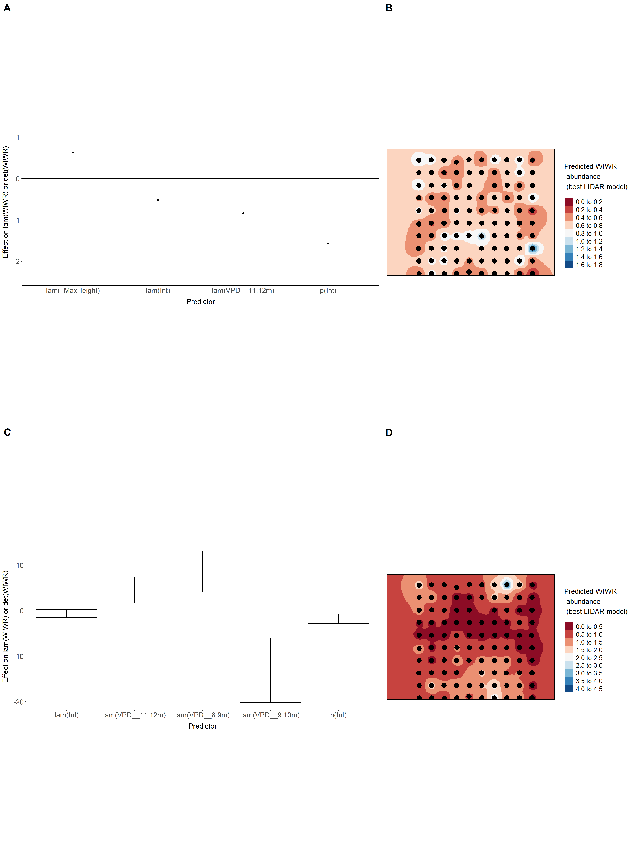

Model coefficients for the best *N*-mixture model predicting abundance of White-throated Sparrow *Zonotrichia albicollis* from LIDAR-based data at the 150-m scale (AIC= 331.48) (A), and 500-m scale (AIC= 336.91) (B), along with predicted abundances of this species in the Kirby grid from these respective models (C-D).

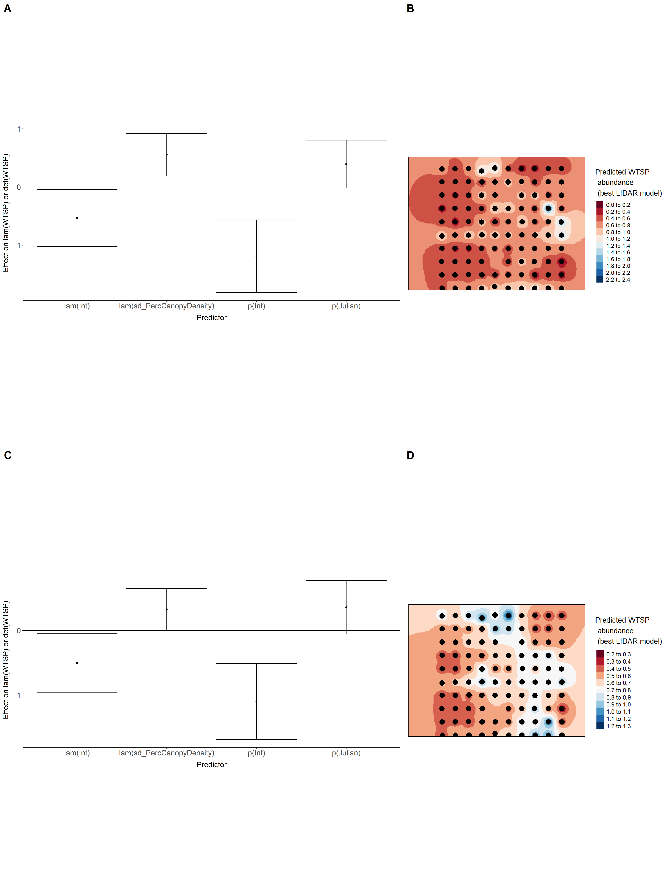

Model coefficients for the best *N*-mixture model predicting abundance of Yellow-rumped Warbler *Setophaga coronata* from LIDAR-based data at the 150-m scale (AIC= 678.17) (A), and 500-m scale (AIC= 682.21) (B), along with predicted abundances of this species in the Kirby grid from these respective models (C-D).

